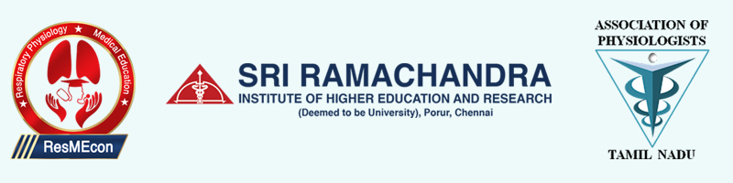
13th Annual Conference - Association of Physiologist of Tamilnadu
ResMEcon-2019 – International Conference on Respiratory Physiology & Medical Education
8th - 9th November 2019
Department of Physiology
Sri Ramachandra Medical College and Research Institute, SRIHER(DU)
ABSTRACT FORM
(To be sent on or before 1st October 2019)

Name of the presenter: _______________________________________
Title of the presenter: Dr/Mr/Ms ________
Department: ________________________________________________
Institution: _________________________________________________
Name of the co-authors: _______________________________________
City: _________________ State: ______________ Pin code _________
Category: Faculty / Student* (UG/PG/Full-time PhD scholar/JRF), Specify__________
Annual/Life member of Association of Physiologists of Tamilnadu: YES / NO
Preference of presentation: Oral / e-Poster
Contact no of presenting author: _________________________________
E-mail id of presenting author: ___________________________________
Title of Presentation: _________________________________________
____________________________________________________________

Signature of the presenter
*Students MUST get this form duly signed by their HOD to register under above mentioned category

